Q18.Retrieve the names of all famers who do not have supervisors.

SELECT farm.farmer.Fname, farm.farmer.Lname

FROM farm.farmer

WHERE LeaderID IS NULL;

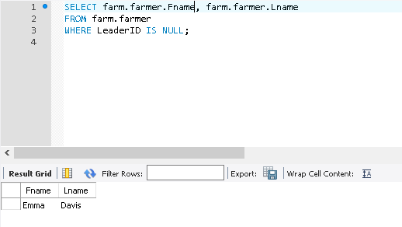

Q.16 Retrieve the name of crop that the total stock is more than 300 tons.

SELECT \* FROM farm.section;

select farm.section.CropName

from farm.section

group by farm.section.CropName

having sum(farm.section.Stock) > 300

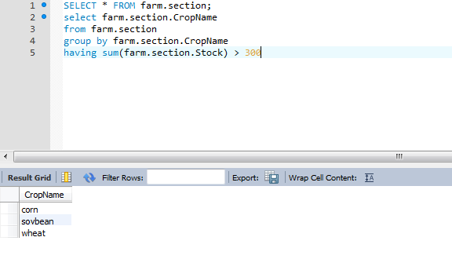

Q6. Retrieve the ID of barns which all the sections are occupied.

SELECT \* FROM farm.section;

select distinct farm.section.﻿BarnID

from farm.section

where farm.section.﻿BarnID not in(select distinct farm.section.﻿BarnID

from farm.section

where farm.section.﻿stock = 0);

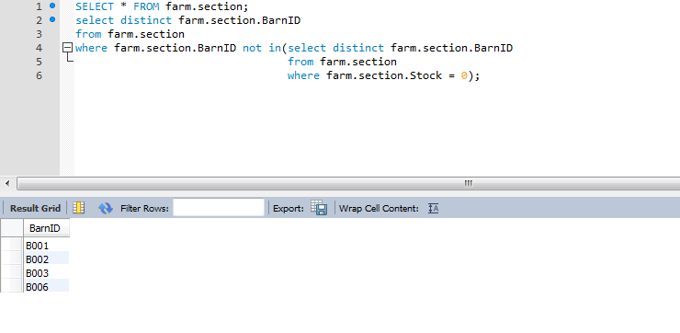

Q7. List the ID of barns and temperature, humidity and stock which store potato.

select farm.section.﻿BarnID, farm.section.Temp, farm.section.Humidity, farm.section.Stock

from farm.section

where farm.section.CropName = 'potato'

